**GRAND COUNCIL OF THE ORDER OF THE ALLIED**

**MASONIC DEGREES OF ENGLAND AND WALES**

**AND DISTRICTS AND COUNCILS OVERSEAS**

**Most Worshipful Brother Thomas Firth Jackson**

**Grand Master**

**DISTRICT OF SURREY**

**R.W.Bro. John Vaughan Christopher French**

**District Grand Prefect**

**W.Bro. Robert G Tuthill, PGStB**

**Deputy District Grand Prefect**

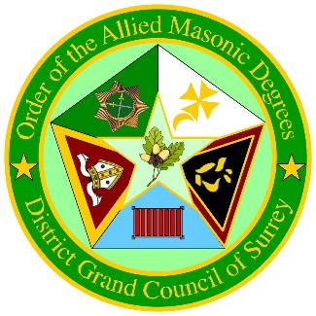

**ORDER OF PROCEEDINGS   
ANNUAL DISTRICT MEETING OF THE  
DISTRICT GRAND COUNCIL OF SURREY**

**SATURDAY 7th DECEMBER 2024  
AT 11.00 a.m.**

**CROYDON AND DISTRICT MASONIC HALL  
73 Oakfield Road, Croydon**

**Surrey CRO 2UX**

**020 8688 2005**

**Followed by Lunch at 1.00 p.m. approx.**

**Brethren to be seated in the Temple by 10.45 a.m.**

**The Right Worshipful District Grand Prefect will enter in procession.**

**AGENDA**

1. District Grand Council will be opened in due form.
2. The Right Worshipful District Grand Prefect will be saluted.
3. To honour Brethren who have been called to a Higher Service.
4. The Right Worshipful District Grand Prefect will welcome all Visitors and Guests.
5. To approve the Minutes of last year’s Annual District Meeting held on Saturday 2nd December 2023.
6. To call the roll of District Grand Officers.
7. To call the roll of Councils within the District.
8. The District Grand Treasurer will submit the audited Annual Accounts for the year to 31st August 2024 for adoption.
9. The District Grand Secretary will submit his Report.
10. The Right Worshipful District Grand Prefect will receive those Brethren newly admitted into the Order since the last Annual Meeting.
11. To elect a District Grand Treasurer.
12. To elect Two District Account Auditors.
13. The Right Worshipful District Grand Prefect will re-appoint his Deputy District Grand Prefect.
14. The Right Worshipful District Grand Prefect will appoint and invest District Grand Officers of the year, and those appointed and promoted in Past District Grand Rank.
15. The Right Worshipful District Grand Prefect will address District Grand Council.
16. A collection for Charity will be taken.
17. To consider any other Allied Masonic business.
18. The District Council will be closed in due form.

**To sing the first verse of The National Anthem**

**The Right Worshipful District Grand Prefect, accompanied by the Deputy District Grand Prefect, Active District Grand Officers and Honoured Guests will retire in procession.**

2

**DISTRICT GRAND OFFICERS**

**2023-2024 OFFICE 2024-2025**

W.Bro. Robert G Tuthill, Deputy District W.Bro. Robert G Tuthill,  
**P.G.St.B.** Grand Prefect **P.G.St.B.**

W.Bro. Barrie Selway Senior Warden W.Bro. Norman Jones

W.Bro. Graham Beer, **P.G.St.B** Junior Warden W.Bro. Michael Mello

W.Bro. Leslie Grout, **P.G.St.B** Chaplain W.Bro. Leslie Grout **P.G.St.B.**

W.Bro. Raymond Seeley Treasurer W.Bro. To be Elected

Bro. Trevor Sadler Secretary Bro. Trevor Sadler

W.Bro. Anton A Smith, Director of Ceremonies W.Bro. Anton A Smith,  
**P.G.St.B P.G.St.B.**

W.Bro. William Barr Deputy D of C W.Bro. William Barr

W.Bro. George Rodger Senior Deacon W.Bro. Denis Leigh

W.Bro. Barry Northmore Junior Deacon W.Bro. Colin Beerling

W.Bro. Alan Hall Assistant D of C W.Bro. Miguel Godfrey

W.Bro. Kevin Brennan Sword Bearer W.Bro. Kevin Brennan

W.Bro. Michael Ellis Standard Bearer W.Bro. John Massey

W.Bro. Alan Brockwell, Assistant Secretary W.Bro. Alan Brockwell,  
**P.G.J.D**.  **P.G.J.D.**

Bro. Robert Soper Organist Bro. Robert Soper

W.Bro. Barry Thomas Inner Guard W.Bro. Bernie Greenwood

W.Bro. Denis Leigh Steward W.Bro. Alan White

W.Bro. Emmanuel O Babajide Steward W.Bro. Ray Johnson

W.Bro. Stephen G Harvey, Tyler W.Bro. Stephen G Harvey,   
**P.G.St.B** **P.G.St.B**

**PAST DISTRICT GRAND RANK 2024 - PROMOTIONS**

Past Senior Warden W.Bro. Steve Jones

Past Senior Warden W.Bro. Alan Zimon

Past Junior Warden W.Bro. Ian N Clark

Past Junior Warden W.Bro. Paul Fitzgerald

Past Junior Warden W.Bro. Mark Guzam, **P.G.St.B.**

Past Junior Warden W.Bro. Alan Hall

Past Junior Warden W.Bro. Bob Hancock

Past Junior Warden W.Bro. Nigel Thomson

Past Senior Deacon W.Bro. Graham Rawlinson

Past Senior Deacon W.Bro. James Jones

**PAST DISTRICT GRAND RANK 2024 - FIRST APPOINTMENT**

3

Past Standard Bearer W.Bro. J Martin Dunham

The Annual Meeting of the District Grand Council is held on the

FIRST SATURDAY in DECEMBER   
at Croydon & District Masonic Hall

Next Year’s Annual Meeting will be held on Saturday   
6th December 2025.

**Please keep up to date with the:**

**District Website:**

[**www.alliedmasonicdegrees.co.uk**](http://www.alliedmasonicdegrees.co.uk)

**&/or:-**

[**www.SurreyAllied.com**](http://www.SurreyAllied.com)

**DISTRICT GRAND COUNCIL OF SURREY**

5

16

**Report of the District Grand Secretary**

**Year to December 2024**

My first year as District Secretary has been a “mostly” interesting and enlightening learning curve- challenging but rewarding “in equal measures”- an overall positive experience.

Membership now standing at 195 (149 Single). During the year we welcomed 14 new members into the Order and 8 Joining Members. We have unfortunately lost 6 members through resignation (mainly resulting from health issues) and 7 to GLA. All the Councils have carried out a variety of Degree workings and the work has generally been of a high standard.

***Regrettably we have lost to Higher Service during the year:***

**R.W.Bro. Mike Whelan,** aged 71, of Southern Cross 13.

**V.W.Bro. Brian Vickers.** aged 87, of Surrey Hills 208.

**W.Bro. Andrew Bridges**, aged 79. of Godalming 185.

**W.Bro. John Marshall.** aged 83, of Godalming 185.

**Bro. Glyn Harvey,** aged 72, of Surrey 64.

**Bro. Keith MacLean**, aged 76, of Pride of Surrey 128.

**Bro. Scott Burns,** aged 61, of Kyngstun 102.

They were highly committed and respected Freemasons, in a number of Orders and we shall greatly miss their friendly and brotherly companionship at our future meetings.,

The Annual Hog Roast was held in July 2024 at Guildford Masonic Centre and was again a hugely successful and well supported event, being attended by in excess of 125 Brethren, family members, visitors and guests. The event was again superbly organised by Bro Kevin Brennan and his Team.

During the year the Right Worshipful District Grand Prefect and his Deputy were accompanied and well supported by District Officers of the year visiting all Councils in the District for at least one of their meetings. The members of the Executive have also been very active in their own Councils and have also visited other Districts throughout the length and breadth of the UK.

On all of these visits we have been very warmly welcomed and have greatly enjoyed the hospitality and fraternal friendship, which has been greatly appreciated. Many of the other Districts will again be represented at our Surrey Annual Meeting today and we extend a very warm welcome to them and do hope that they very much enjoy their day with us.

At the Annual meeting of Grand Council on 24th October 2024 held at Freemasons’ Hall in London, the following members of Surrey Councils were honoured by the Most Worshipful Grand Master and we congratulate them on their preferment: -

**First Appointments**

**W.Bro. David J Blackburn** Past Grand Junior Deacon

**W.Bro. David M Willmott** Past Grand Junior Deacon

**W.Bro. Hugh J Everitt** Past Grand Standard Bearer

Grateful thanks from me to- ***in no particular order***:-

* My predecessor **W.Bro. Alan B**- “still in the wings” ready and willing to answer queries “when properly called upon”.
* Our District Treasurer **W.Bro. Ray S**- “who has a phenomenal grasp and understanding on what makes the District tick”
* DGP **R.W.Bro. John Frence,** our Surrey AMD driving force, who despite a ridiculous number of home and personal challenges this year, has continued to be laser focussed on promoting Surrey AMD- he’s a colossus !!
* Each and every of the 9 Councils Secretaries - without their input the District simply would not function.
* All the current and future District Officers who have supported the DGP and his Deputy on many visits to our Councils.
* All Surrey AMD members- who promote the Order by spreading the word - it’s a TEAM effort- we need new blood to thrive.

Onwards and upwards is the only way to go !

Recruit, Recruit, Recruit.

**Trevor J Sadler  
*District Grand Secretary  
2nd December 2024***

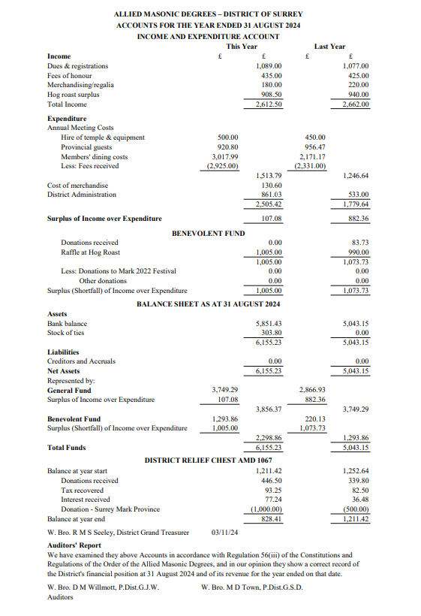

**COUNCILS IN THE DISTRICT**

**Southern Cross Council No XIII  
4th Wednesday in April and 3rd Wednesday in September (Inst)**Meeting at Surbiton (April) & Guildford (September)

**Surrey Council No 64  
3rd Monday in February and December & 1st Monday in June (Inst)  
Meeting at Croydon**

**Kyngstun Council No 102  
2nd Tuesday in May & 1st Wednesday in September (Inst)  
Meeting at Surbiton**

**Pride of Surrey Council No 128  
1st Tuesday in April and 1st Friday in June (Inst)**Meeting at Sutton

**Godalming Council No 185  
2nd Monday in January (Inst) & 3rd Friday in July**Meeting at Godalming

**Runnymede Council No 191  
1st Friday in February and May & 2nd Friday in October (Inst)**Meeting at Surbiton

**Surrey Hills Council No 208  
3rd Wednesday in April and 1st Tuesday in November (Inst)**Meeting at Nutfield (Redhill)

**Riverside Council No 212  
3rd Thursday in February (Inst) & 1st Tuesday in September**Meeting at Guildford

**Farnham Council No 235  
3rd Monday in May (Inst) & 1st Wednesday in November**Meeting at Farnham

**Printed by Spectrum Printing & Mailing Services Tel: 01932 569123**